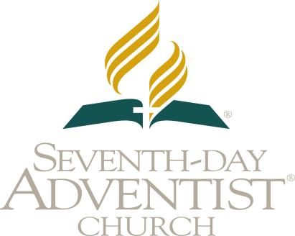


CONFERENCE OR MISSION
HEALTH ACTIVITIES REPORT
SOUTHERN AFRICA INDIAN OCEAN DIVISION

Name of Conference or Mission: Phone:
Address: Email Address:
Union Located
Period of Reporting: Union Located:
Total Districts: Districts Reporting:

SUMMARY: HEALTH ACTIVITIES FROM ALL THE DISTRICTS IN THE MISSION or CONF | TOTAL
1. Comprehensive and Blended Ministries Health Promotions
2. CELEBRATIONS Promotions
3. NEWSTART Lectures
4. Cancer Prevention
5. International Commission for Prevention of Alcohol & Other Dependencies
Stop Smoking
Fight Against Alcoholism and its use
Drug Awareness
Campaigns and Help Against Addictions (Pornography, Video Games, etc)
6. HEALTH EXPO
7. Health Programs with Evangelistic Efforts
8. Number of Baptisms due to Health and Evangelism programs
9. Radio &TV Health Programs Broadcasting
10. Health Programs using Social Media Platform (Facebook, You Tube, Twitter, etc)
11. Health Programs in conjunction with Government and other NGOs
12. Maternal Health, Child Health and Malnutrition Campaigns
13. Vegetarian cooking demonstrations and nutrition classes
14. Vaccination Promotion
15. Non-Communicable Diseases Prevention (high BP, Diabetes, Obesity, high Cholest)
16. Mental Health
17. AIDS & HIV- Orphan and People Living with HIV care
AIDS & HIV- Voluntary Counseling and Testing
AIDS & HIV – Income Generating Activities
AIDS & HIV Awareness- Fight Against Stigma and Discrimination
18. Other Health Programs not listed above like Youth Alive and others

Reported by: Designation
Date of Reporting:

